Department of ECE,Gayatri vidhya parishad COE

ELECTRICITY BILL GENERATOR

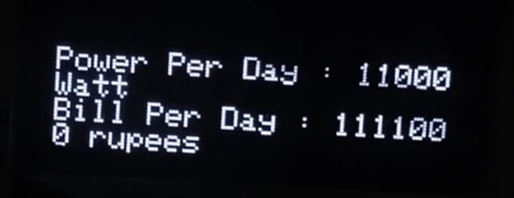

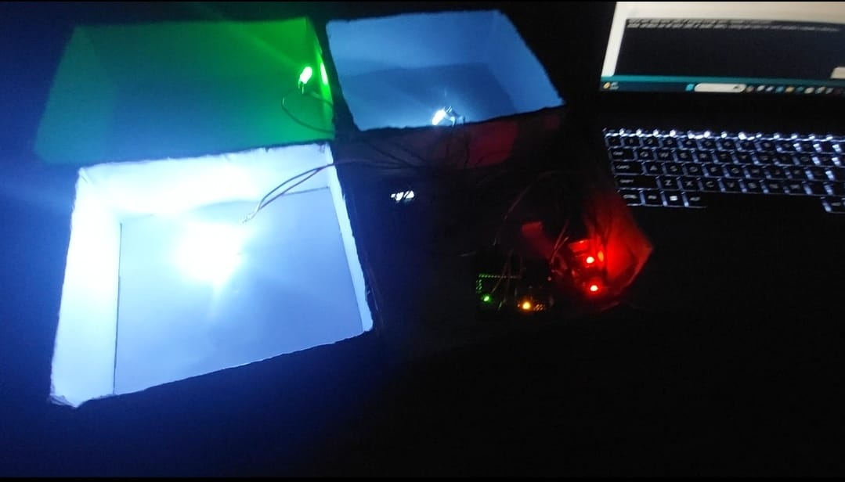

**Conclusion:**

**By leveraging the capabilities of Arduino microcontrollers and OLED displays, the Electricity Bill Modulator offers a practical and cost-effective solution for monitoring and managing electricity consumption. This project not only promotes energy conservation but also empowers users to make informed decisions regarding their energy usage, ultimately leading to reduced costs and a more sustainable future.**

**REFERENCES:**

**Chatgpt,Google,Youtube.**

**Testing and Calibration:**

**Test the setup to ensure accurate readings from the sensors.**

**Calibrate the sensors if necessary to improve accuracy.**

**Validate the displayed data against actual energy usage to ensure reliability.**

**Integration and Deployment:**

**Once everything is working correctly, integrate the components into a single system.**

**Ensure the setup is safe and reliable for long-term use.**

**Deploy the system in your desired location to monitor electricity usage**

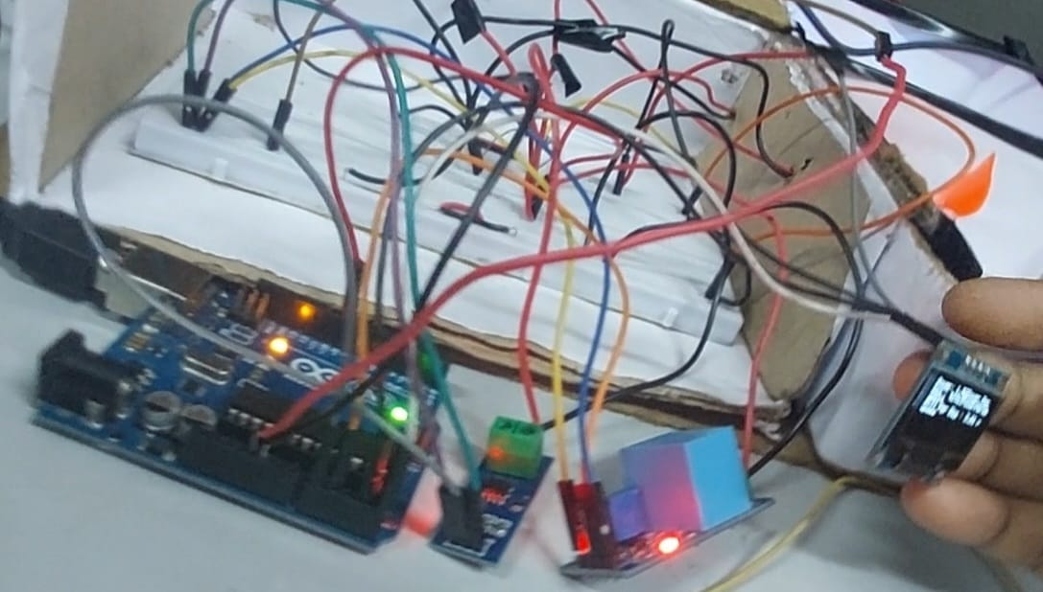**.**

**FLOW CHART**

Start  Initialize Components Main LoopRead Voltage and Current from Sensors Calculate Power  Update OLED Display with Power Consumption Calculate Energy Consumption over Time  End

**Introduction:**

**In today's world, where energy conservation and cost efficiency are paramount concerns, monitoring and managing electricity consumption at a granular level has become increasingly important. The integration of modern technology, such as Arduino microcontrollers and OLED displays, offers a practical solution for individuals and businesses alike to monitor and modulate their electricity usage effectively. In this project, we present an Electricity Bill Modulator utilizing an Arduino Uno microcontroller along with OLED display, current, and voltage sensors.**

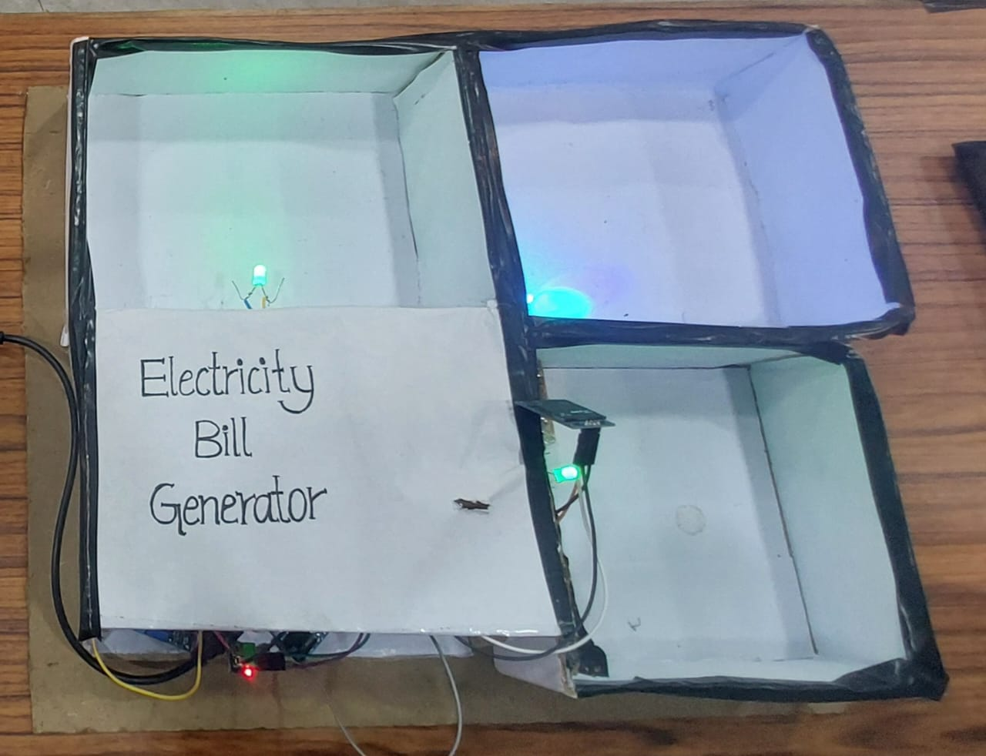

To create an electricity bill modulator using an Arduino Uno, OLED display, current sensor, and voltage sensor, you'll typically follow these steps:

Hardware Setup:

Connect the OLED display to the Arduino Uno according to its datasheet.

Connect the current sensor and voltage sensor to the Arduino Uno. These sensors will typically have three pins: VCC, GND, and SIGNAL. Connect VCC to a 5V pin on the Arduino, GND to a GND pin, and SIGNAL to an analog input pin.

Code Development:

Write the Arduino code to read data from the current and voltage sensors.

Calculate power (P) using the formula P = V * I, where V is voltage and I is current.

Calculate energy consumption (E) over time (e.g., in Watt-hours or kilowatt-hours).

Implement logic to display real-time power consumption and accumulated energy

on the OLED display.

You may also incorporate features like peak usage tracking, cost estimation based on electricity rates, etc.